**USE CASE TEMPLATE**

|  |  |  |  |
| --- | --- | --- | --- |
| Use Case ID: | 1 | | |
| Use Case Name: | Capture Marksheets | | |
| Created By: | Vamshi Bachu, Bharat Simha Reddy | Last Updated By: | Vamshi Bachu |
| Date Created: | 09-02-2024 | Date Last Updated: | 22-03-2024 |

|  |  |
| --- | --- |
| Actors: | Users |
| Description: | Users use the camera to capture the mark sheet. |
| Preconditions: | The user must be logged into the application |
| Post conditions: | The image of the marksheet is captured and now it is ready for the ocr processing |
| **Normal Flow:** | 1. The user selects the "Capture Mark Sheets" option  from the application's menu.  2. The user activates the device's camera.(A-1)  3. The user aligns the camera to capture the image of  the mark sheet.  4. The user captures the image.  5. The captured image is displayed for review.(A-2)  6. The user confirms the image and the image will be  processed |
| **Alternative Flows:** | A-1 : if the device camera is not activated , the user is  prompted to grant permission to access the camera.  A-2: If the user thinks that the captured image is not  clear or did not capture the marksheet properly  they can retake the image. |
| Exceptions: |  |
| Includes: | User Authentication |
| Priority: | High |
| Frequency of Use: | Frequently |
| Business Rules: |  |
| Assumptions: | User have access to a device with a functioning camera. |

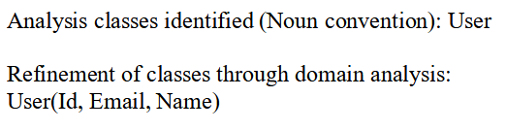

**Activity Diagram for Capture Marksheets**

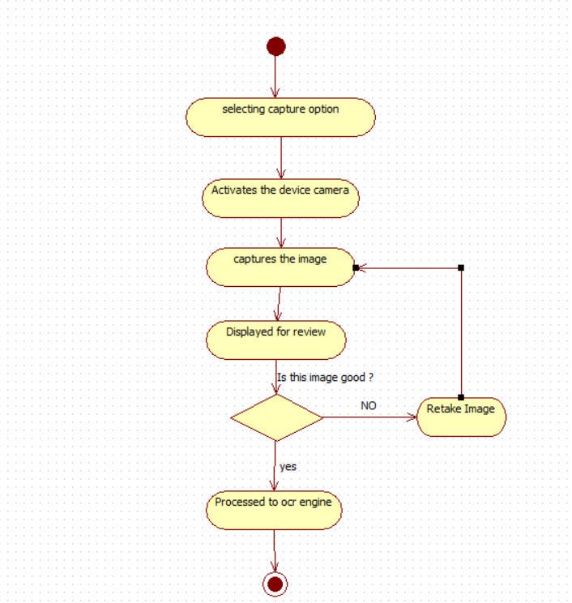

**Sequence Diagram for Capture Marksheets**

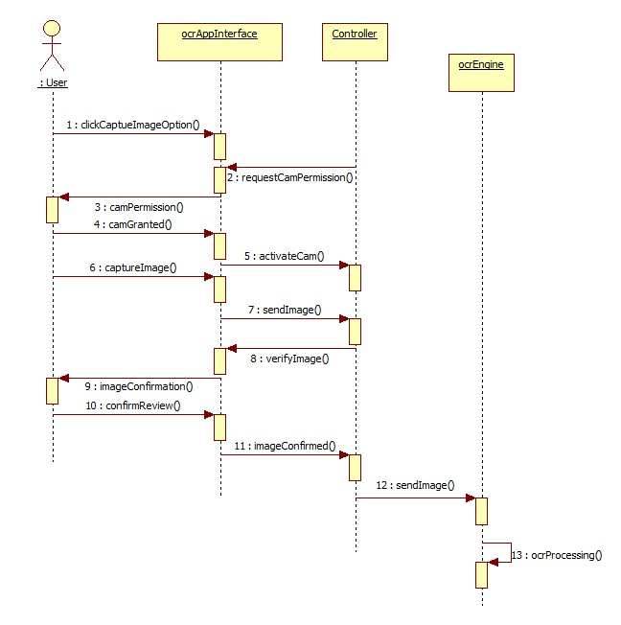

|  |  |  |  |
| --- | --- | --- | --- |
| Use Case ID: | 2 | | |
|  |  | | |
| Use Case Name: | User Authentication | | |
| Created By: | Vamshi Bachu, Bharat Simha Reddy | Last Updated By: |  |
| Date Created: | 19-02-2024 | Date Last Updated: |  |

|  |  |
| --- | --- |
| Actors: | User |
| Description: | The process for the user to log in into the application |
| Preconditions: | →The user should have an account.  →The user needs to have internet connectivity.  →The application is installed and launched on a device that meets the system requirements. |
| Post conditions: | →The user is successfully logged in to the application.  →The user can view and manage their account information.  →The user can access all functionalities available to them within the application. |
| **Normal Flow:** | 1.The user opens the OCR MARK SHEET application.  2.The login screen is displayed.  3.The user enters their username and password.  4.The application authenticates the credentials against the user database.  5.If the credentials are valid:(A-1)  →The user is granted access to the application.  →A session token is generated and stored securely. |
| **Alternative Flows:** | (A-1)The Credentials you have entered are incorrect please re-enter the credentials. |
| Exceptions: | Server Issues |
| Includes: | Account Creation |
| Priority: | High |
| Frequency of Use: | frequently |
| Business Rules: | None |
| Assumptions: |  |



**Sequence Diagram for User Authentication**

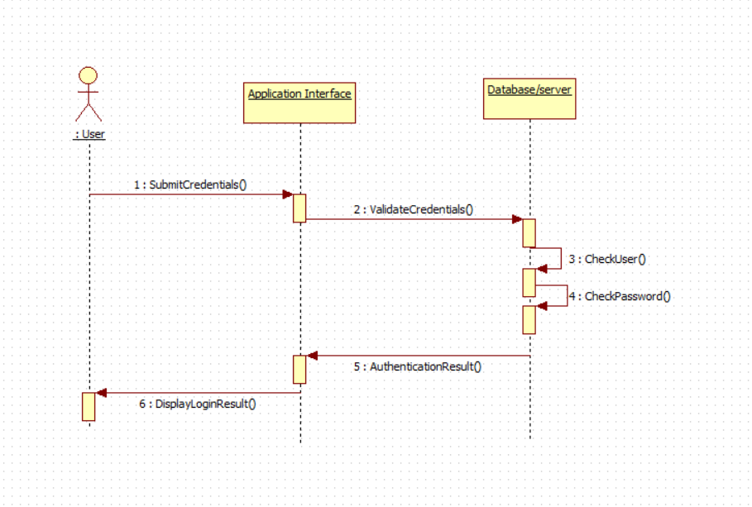

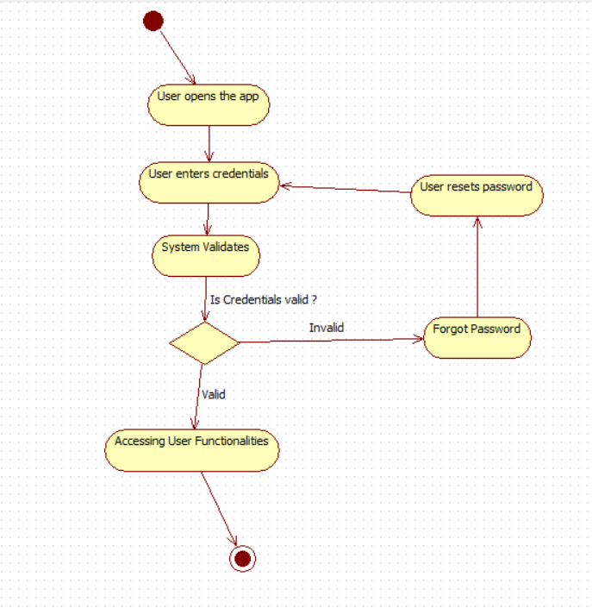**ACTIVITY DIAGRAM**

|  |  |  |  |
| --- | --- | --- | --- |
| Use Case ID: | 3 | | |
| Use Case Name: | User creation | | |
| Created By: | Vamshi Bachu, Bharat Simha Reddy | Last Updated By: |  |
| Date Created: | 19-02-2024 | Date Last Updated: |  |

|  |  |  |  |
| --- | --- | --- | --- |
| Use Case ID: | 3 | | |
|  |  | | |
| Use Case Name: | User creation | | |
| Created By: | Vamshi Bachu, Bharat Simha Reddy | Last Updated By: | Vamshi Bachu |
| Date Created: | 19-02-2024 | Date Last Updated: | 23-03-24 |

|  |  |
| --- | --- |
| Actors: | Administrator |
| Description: | The process of an administrator creating a new user account in the OCR MARK SHEET application. |
| Preconditions: | The administrator has access to the "Create User" functionality. |
| Post conditions: | A new user account is created with the specified details. |
| **Normal Flow:** | 1.The administrator selects the "Create User" option.  2.The administrator enters the new user's information, including:  →Username  →Password  →Email address  →First name  →Last name  →Role (e.g., student, staff)  →(Optional) Additional user details as needed.(A-1)  3.The administrator chooses the initial application permissions for the new user based on their role.  4.The administrator reviews the entered information and confirms creation.  5.The system validates the information and creates the new user account.  6.(Optional)An email notification with login credentials is sent to the new user's email address. |
| **Alternative Flows:** | (A-1)The administrator entered invalid or incomplete information. please correct the information |
| Exceptions: |  |
| Includes: |  |
| Priority: | Low |
| Frequency of Use: | Less |
| Business Rules: |  |
| Assumptions: | The administrator has accurate information about the new user. |

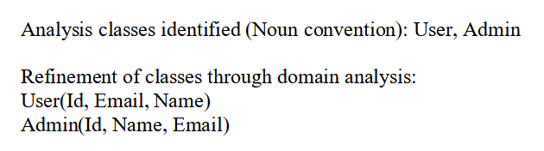

Sequence Diagram for User Creation

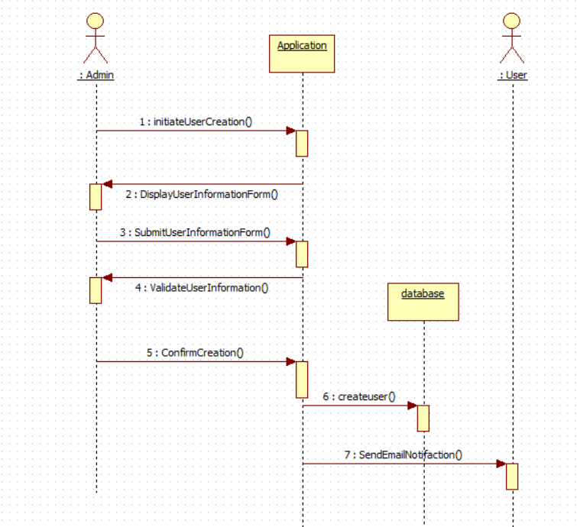

**Activity Diagram For User Creation**

